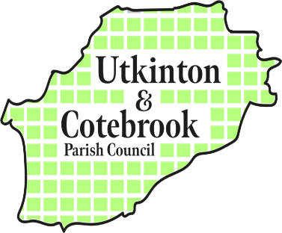
ANNUAL MEETING OF THE PARISH

6 – 6.45pm on Monday 12th May 2025
@ Cotebrook Village Hall

MINUTES

- Present: Cllr Marian Atkinson, Cllr Matthew Grant, Cllr Andrew Needham, Cllr Stephen Moore, Cllr Graham Spencer, Cllr Graham Stewart, Cllr Caroline Stubbs plus five residents and CWaC Cllr Charles Hardy,
Apologies were accepted from Cllr Sami Kasteniemi, Nick Parker, Cllr Ed Stubbs

- The Chairman of the Parish Council Cllr Graham Spencer welcomed residents and parish councillors to the meeting and explained that this was not a formal parish council meeting but an opportunity to share priorities and information with the local community and parish councillors. He shared copies of the latest edition of the Parish Times, which will be delivered to every household in the parish and invited residents to join parish councillors at Tirley Garth on 14th June for the Big Community Festival which has been jointly organised by the two village halls, the church, the WI and the parish council – a fabulous example of how the community is working together effectively for the good of all.

- Presentation from Cllr Andrew Needham and Francis Tunney on the recent Land Availability assessment by Cheshire West and Chester.
- Questions and Answers: Cllr Spencer thanked Mr Tunney and Cllr Needham for their input and invited questions from the audience. There was concern expressed about large scale development in the area and CWaC Cllr Hardy reassured everyone that no decisions had been made and that there were land plots that had been displayed as “potential development” that were very unlikely to be built on. Utkinton and Cotebrook do have a Neighbourhood Plan which was accepted by CWaC in 2021 and has restrictions to inappropriate building plans.

Cheshire West and Chester Council are providing an information session on how to best review Neighbourhood Plans in the next few weeks which will attended by members of the parish council and at the June Parish Council meeting, a review of the 2021 Plan will be proposed. This will involve the creation of a local working party and residents will be invited to take part.

- Cllr Grant ended the meeting by sharing a copy of a Remembrance Book created to mark the 150th Anniversary of St Johns Church in Cotebrook.

6.45pm Meeting closed.

