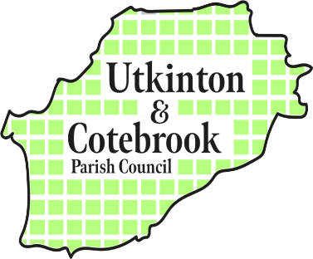
Councillors are summoned to attend the
UTKINTON AND COTEBROOK PARISH COUNCIL MEETING
To be held at Rose Farm Coffee Shop on
Monday 9th June 2024 at 7pm

Clerk & RFO: Kath Lloyd

Email: utkintonandcotebrookclerk@gmail.com

PART ONE - PUBLIC AGENDA

09.06.01 | Information Update from United Utilities – an update on the large green water tank in Utkinton  *Please note that there will be a short time allowed for questions but any questions not answered will be noted by the Clerk and passed to the team for a future meeting.
09.06.02 | Public Open Forum  In accordance with the Councils’ Standing Orders, a period of not exceeding 15 minutes will be put aside at the start of the meeting for members of the public to ask a question or make a statement about any matter relating solely to any function of the Council or to any planning application being considered by the Council. Anyone wishing to ask a question is requested to inform the Clerk before the meeting. | Chair
09.06.03 | To note attendance and approve any apologies for absence | Chair
09.06.04 | Declarations of Interest: To receive any declarations of new interest. | Chair
09.06.05 | Minutes of Parish Council meeting of 12th May 2025: To approve and sign the minutes of the previous council meeting. | Chair
09.06.06 | Cheshire West & Chester Council Matters: To receive a report from elected CWaC Councillor. | Chair
09.06.07 | Planning Applications:  09.06.07.1 To note applications received and agree or ratify a response to the following applications and to consider applications received since the publication of this agenda  09.06.07.2 To note decisions received
  Ref No | Site Address | Proposal | Response
  Ref No | Site Address | Proposal | Decision
  ---------- | ---------------- | -------------- | -------
09.06.08 | Neighbourhood Plan Review: to establish a Working Party to review the Neighbourhood Plan and agree the Terms of Reference | Chair
09.06.09 | Work Programme: to receive updates on the following:  09.06.09.1 Planters at Cotebrook bus stop  09.06.09.2 United Utilities response to letter  09.06.09.3 Big Community Festival  09.06.09.4 Salt Bin | All
09.06.10 | Correspondence: to note correspondence from residents received since the last meeting:  09.06.10.1 Unkept footpaths along Wood Lane  09.06.10.2 Poor state of Oulton Mill Road, Cotebrook | All
09.06.11 | Finance Matters  09.06.11.1 To approve accounts for payment and note accounts paid since 12th May 25  09.06.11.2 To note the bank balance and cash book at the end of May 2025
09.06.12 | Councillor’s reports and items for future agenda: Each councillor is requested to use this opportunity to report minor matters of information not included elsewhere on the agenda and to raise items for future agendas. Councillors are respectfully reminded that this is not an opportunity for debate or decision making. Please continue to contact the Clerk for her to deal with any issues as and when they arise between meetings. | All
09.06.13 | Date of future meetings  See below | All

At Cotebrook Village Hall, Stable Lane, Cotebrook CW6 0JJ | At Rose Farm Coffee House, John Street, Utkinton CW6 0LP
Monday 14th July at 7pm  Monday 13th October at 7pm  Monday 8th December at 7pm  Monday 9th February 2026 | Monday 8th September at 7pm  Monday 10th November at 7pm  Monday 12th January 2026 at 7pm

