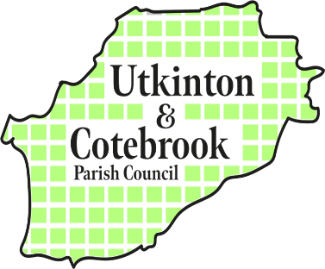
ANNUAL MEETING OF THE PARISH

6 – 6.45pm on Monday 11th May 2026
@ Rose Farm Coffee House, John Street, Utkinton

MINUTES

- Present: Cllr Marian Atkinson, Cllr Matthew Grant, Cllr Sami Kasteniemi, Cllr Andrew Needham, Cllr Stephen Moore, Cllr Graham Spencer plus one resident and CWaC Cllr Charles Hardy,
Apologies were accepted from Cllr Caroline Stubbs and Cllr Ed Stubbs

- Minutes of Annual Parish Meeting 2025: Cllr Kasteniemi proposed that the minutes of the meeting held on 12th May 2025 be accepted as accurate, seconded by Cllr Atkinson and motion carried.

- Chairmans’s Report: The Chairman of the Parish Council Cllr Graham Spencer welcomed residents and parish councillors to the meeting and explained that this was not a formal parish council meeting but an opportunity to share priorities and information with the local community and parish councillors. He referred to the forthcoming Parish Times newsletter which will be delivered to all homes in the parish within the next week or two and contains details of the work that the Parish Council has carried out over the last year. He gave the following report:

Dear Councillors and Members of Our Community,
As we reflect on the past year, I would like to take this opportunity to express my sincere thanks to everyone who has contributed to the continued strength and success of our parish.
First and foremost, I extend my thanks to my fellow councillors. Your dedication, thoughtful contributions, and willingness to give your time freely have been invaluable. The challenges we have faced this year have required cooperation, resilience, and careful decision-making, and I am proud of the way we have worked together in the best interests of our community.
I would also like to recognise the contribution of our parish clerk, whose professionalism and commitment ensure the smooth running of council business. Kath’s work often goes unseen, but it is essential to everything we achieve.
To the members of our community, thank you for your continued support, engagement, and trust. Whether by attending meetings, volunteering, raising concerns, or simply taking pride in our local area, your involvement plays a vital role in shaping the parish we all share.
This year has brought both progress and challenges. We have made strides in improving community spaces, and supporting initiatives that enhance the quality of life for residents. At the same time, we remain mindful of the work still to be done and the importance of listening to the needs and aspirations of our parish.
As we look ahead, I am confident that by continuing to work together—with openness, respect, and a shared sense of purpose—we can build on these achievements and ensure a positive future for our community.
Thank you once again to everyone who has contributed in any way over the past year.
- Questions and Answers: Mr Francis Tunney, the resident present asked Councillors to note that he has lived in the parish for 35 years and has never seen the roads in such a poor state. He asked that the Parish Council put as much pressure as possible on the Borough Council to pay more attention to rural roads.
Cheshire West and Chester Ward Cllr Charles Hardy responded and agreed that he was as frustrated as everyone else at the state of the roads and assured the meeting that he brings the issue up at every CWaC Cabinet Meeting. There was a discussion about the proportion of Council Tax paid by parish residents against the proportion spent by the Borough Council on rural roads. Mr Tunney offered to submit a Freedom of Information request to collect the information and will feedback to the Parish Council. The Chairman thanked him for the constructive and helpful offer.

There was also a discussion about the new rural Bus Service Your Bus (Community transport) | Cheshire West and Chester Council and it was agreed that the criteria to access the service is far too restrictive and that many local residents will not be able to use the service, despite there being no public transport in the area. The Clerk to the Parish Council was asked to write to CWaC and express the disappointment of local residents and Councillors.

6.45pm The Chairman thanked everyone for attending and closed the meeting.

