Councillors are summoned to attend the
UTKINTON AND COTEBROOK PARISH COUNCIL MEETING
To be held at Cotebrook Village Hall on
Monday 8th June 2026 at 7pm

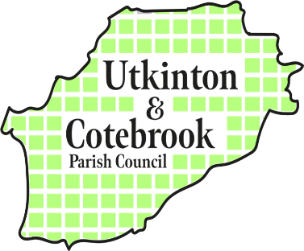

Clerk & RFO: Kath Lloyd

Email: utkintonandcotebrookclerk@gmail.com

PART ONE - PUBLIC AGENDA

08.06.01 | Public Open Forum  In accordance with the Councils’ Standing Orders, a period of not exceeding 15 minutes will be put aside at the start of the meeting for members of the public to ask a question or make a statement about any matter relating solely to any function of the Council or to any planning application being considered by the Council. Anyone wishing to ask a question is requested to inform the Clerk before the meeting. | Chair
08.06.02 | To note attendance and approve any apologies for absence | Chair
08.06.03 | Declarations of Interest: To receive any declarations of new interest. | Chair
08.06.04 | Minutes of Parish Council meeting of 13th May 2026: To approve and sign the minutes of the previous council meeting. | Chair
08.06.05 | Cheshire West & Chester Council Matters: To receive a report from elected CWaC Councillor. | Chair
08.06.06 | Planning Applications:  08.06.06.1 To note applications received and agree or ratify a response to the following applications and to consider applications received since the publication of this agenda  08.06.06.2 To note decisions received
  Ref No | Site Address | Proposal | Response
  Ref No | Site Address | Proposal | Decision
  ---------- | ---------------- | -------------- | -------
08.06.07 | Community Events Update: to note an update on progress | Cllr MG
08.06.08 | Dog Show: to note an update on progress made and agree any actions needed. | Cllr MA & Cllr CS
08.06.09 | Cotebrook Community Orchard: to note any updates and agree a plan to improve the  area. | All
08.06.10 | Peak Cluster Update: to note the response received to the Parish Council’s submission to  the consultation
08.06.11 | Finance Matters  08.06.11.1 To approve accounts for payment and note accounts paid since 13th May 2026  08.06.11.2 To note the bank balance and cash book at the end of May 2026  08.06.11.3 To agree the Annual Governance Statement 2025-2026  08.06.11.4 To agree the Accounting Statements for 2025 -2026 | All
08.06.12 | Councillor’s reports and items for future agenda: Each councillor is requested to use this opportunity to report minor matters of information not included elsewhere on the agenda and to raise items for future agendas. Councillors are respectfully reminded that this is not an opportunity for debate or decision making. Please continue to contact the Clerk for her to deal with any issues as and when they arise between meetings. | All
08.06.13 | Date of future meetings  See below | All

At Cotebrook Village Hall, Stable Lane, Cotebrook CW6 0JJ | At Rose Farm Coffee House, John Street, Utkinton CW6 0LP
NO MEETING IN AUGUST  Monday 14th September at 7pm  Monday 9th November at 7pm | Monday 13th July at 7pm  Monday 12th October at 7pm  Monday 14th December at 7pm

